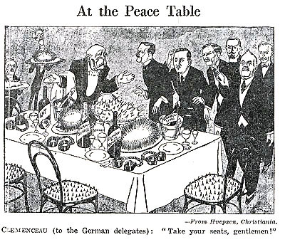
A British cartoon published in August 1919.

- The Germans were not invited to the Peace conference so why are they in this cartoon?
- What do you notice about the seats?
- What does this tell us about Clemenceau’s treatment of them?
- Why would a British person make this cartoon?

